Toxicology procedures for Drosophila melanogaster strains

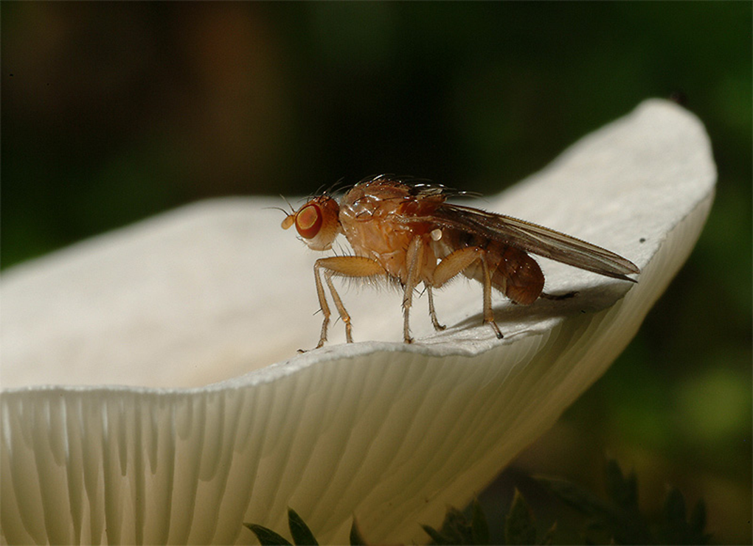
Written by Thomas Werner, 2012
Filling Food Vials
Introduction. In order to determine the lethal dose 50 (LD₅₀) of a Drosophila melanogaster (D. melanogaster) strain to a toxin, 2-mL test tubes need to be prepared for each toxin concentration and experiment. Each tube will contain 500 mg of wet food and house ten larvae.
How many vials do you need? Let’s say you want to test the resistance of a D. melanogaster strain to alpha-amanitin between 0 and 10 ug of alpha-amanitin per gram of food in one-microgram increments. In order to do this, you need to prepare 10 tubes for each of the 11 concentrations you want to test (including the 0-concentration), which is 110 tubes. Furthermore, you will have to repeat this experiment as many times as it takes to get tree experiments with very good data.
Because alpha-amanitin is very expensive ($197 per mg), we will only use 500 mg (half a gram) of wet food per test tube for the larvae to eat. Use a fine balance and a weighing paper to weigh out 0.125 g of dry instant Drosophila food and pour the food flakes through a small funnel into a 2-mL test tube. Fill all 110 tubes this way. Make sure that the balance is clean, that you zero it with the weighing paper on it, and that the balance is leveled. Check the air bubble in the level on the back side of the balance. It is important that the measurements are accurate (0.125 to 0.128 g are acceptable). Close the tubes with the food flakes for storage. Using a black, water-resistant sharpie, label the lids of ten vials with “0”, the next ten vials with “1”, and so on until the number “10”. These numbers stand for ug alpha-amanitin per g of food and are needed to identify the toxin concentrations later during the experiment.
Tip: Prepare as many of these tubes as you can ahead of time. Usually about 50% of the experiments will fail without your fault. Thus, you need at least 660 filled food tubes to successfully measure the LD₅₀ of a single D. melanogaster strain. You can store the filled tubes in racks indefinitely.
Poisoning Food Vials
Introduction. The poisoning of the food has to be done in the toxin lab Dow 705B. You will need the sub-master key to get into the outer door, the lab key to get into the inner door, and the toxin key to open the freezer in which the concentrated alpha-amanitin stock (1 ug/uL) in 100 uL aliquots is stored. We want to make 500 mg (1/2 g) wet food portions for every 2-mL food vial. Because 1 uL of water equals 1 mg, you have to add 375 uL liquid to the 0.125 g dry food to make 500 mg of wet food. The liquid is either plain or toxic MQ water at different concentrations.
Poisoning the food. Every experiment needs a 0-concentration control (10 food vials), which is 375 uL of sterile MQ water per vial. You find the water in the fridge. Always start with the 0-concentration first and then work yourself gradually towards the highest toxin concentration, never the other way! To make the 0-concentration, fill a 15-mL tube with 3.8 mL sterile MQ water (use the pipette boy and a 10 mL tip that you will put back for re-use). With a micro pipette, pipette 375 uL aliquots into the first 10 vials that are labeled with the number “0” on the lid. The wet food will turn blue. Close the tubes after you are done with a set of 10 tubes. There should still be a small drop of about 50 uL left in the 15-mL tube. Using the volumes in the table, add sterile MQ water and alpha-amanitin stock solution to the same 15-mL tube. Important: Screw the lid onto the 15-mL tube, invert it a few times to mix the toxin solution, gently tap any droplets down into the liquid, and pipette 375 uL aliquots into the ten 2-mL tubes labeled with number “1”. Close the lids and do so for the tubes labeled with “2” and so on until number “10”. Do not worry about the residual volume of about 50 uL that always stays in the 15-mL tube after the 10th vial of each concentration is filled. It is supposed to be like that because it prevents you from running out of toxic solution before the 10th vial is filled.
Concentration  [ug alpha-ama / g wet food] | Water into 15-mL tube | Alpha-ama into 15-mL tube
0 (Do this first) | 3.8 mL | 0 uL
1 | 3.75 mL | 5 uL
2 | 3.75 mL | 10 uL
3 | 3.75 mL | 15 uL
4 | 3.75 mL | 20 uL
5 | 3.75 mL | 25 uL
6 | 3.75 mL | 30 uL
7 | 3.75 mL | 35 uL
8 | 3.75 mL | 40 uL
9 | 3.75 mL | 45 uL
10 (Do this last) | 3.75 mL | 50 uL

Be sure to pipette the 375 uL straight onto the dry food and leave no droplets on the wall of the tubes. Then close the lids of the 2-mL food tubes every time you are done with one concentration. Freeze the tubes if you don’t use them on the same day.
Getting first-instar larvae (L1) to populate the 2-mL food vials
General considerations. You need to have a large-enough starting population of your D. melanogaster strain. Maintain the stock in six bottles that you bump once per week. The time from the fertilized egg to the hatched fly is about 10 to 14 days but varies depending on the temperature, humidity, fly strain, (and also the toxin in the experiments). Make sure to familiarize yourself with the life cycle and developmental time of your flies by observing them and taking notes. At room temperature, it takes about 12 – 14 days for the flies to develop from the egg. At 25ºC, it usually takes only 10 days. Provide all new bottles with some sprinkles of dry Baker’s yeast. When you have a bottle of freshly hatched flies, transfer the flies to egg-lay bottles at a rate of about 200 – 300 flies per egg-lay bottle. Avoid overcrowding and undercrowding.
Egg-lay bottles are made of: a plastic bottle with holes in the side, a Kimwipe inside the bottle, an egg-lay cap with molasses agar that will serve as the lid of the bottle, a streak of fresh Baker’s yeast paste on the molasses (use good judgment of how much yeast these flies can eat until you change the caps half a day later), and tape (folded on each end) that fixes the lid to the bottle. The egg-lay bottles will be laid on their side in the incubator at 25ºC and 70% humidity. The egg-lay caps need to be changed twice a day (with fresh yeast on the new caps). The used caps can be washed off and used a few more times again if they are stored in the fridge. At least every two days, the flies need to be bumped over into clean egg-lay bottles because the paper gets dirty. Prevent the dirty paper to fall into the new bottle by letting the flies climb upwards into the new bottle and using a little acrobatics to shake the last flies over. The dirty bottles shall be closed to prevent the last flies from escaping and frozen to kill any remaining flies and eggs before they are washed. It is not necessary to autoclave them.
Females need enough fresh yeast at all times in order to develop their ovaries during the first four days of their lives. Also later during their life, they need yeast to lay many high-quality eggs. Females lay the most eggs when they are 4 – 6 days old and become useless when they are older than 10 days. It is therefore necessary to keep an eye on the age of your flies. During the morning and in the afternoon, there is one peak time each of intense egg-laying. The better you treat your flies (keep them clean and feed them with fresh yeast paste), the more eggs you will get. However, if the yeast is old and brown, the females will retain their eggs in their abdomens, even if they are already fertilized.
Fresh yeast paste is made from scratch by mixing dry Baker’s yeast in a closely-sealing plastic jar with distilled water in a way that it forms a paste. Let the mixture stand at room temperature for an hour until it smells like fruit and raises. If the paste is too liquidly, add a bit more dry yeast to it. Then it is ready to be used. Fruit flies like the yeast this way and they hate old, brown yeast. Store unused yeast paste in the fridge at 4ºC. Every day before you use the yeast paste, mix some new yeast grains into the older paste so that there is always living yeast in the paste. Add some additional distilled water, if necessary. If you don’t add new yeast and keep using old yeast for over a week, the yeast turns brown and becomes bad, which will decrease the willingness of the females to lay eggs.
Below is a D. melanogaster life cycle diagram that you have to be familiar with before you can do any experiments.
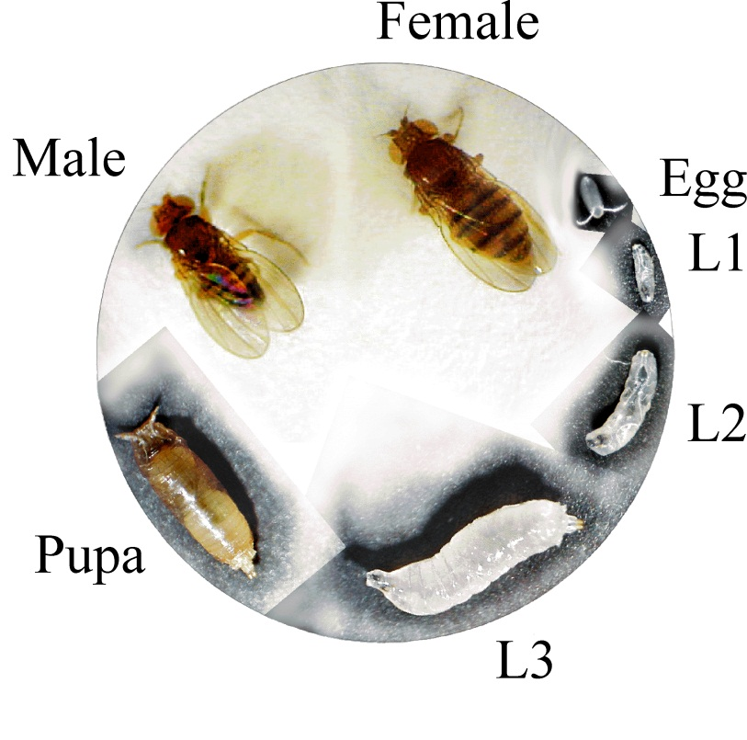
Egg to adult time = 10 days at 25ºC, 14 days at 20ºC, and longer on toxic food
Egg = ~1 day (22 h at 25 ºC)
L1 = ~1 day
L2 = ~1-2 days
L3 = ~2-3 days
Pupa = ~4-6 days
Fly = over 2 months, females lay the most eggs at age 4 – 6 days
For one experiment, you will need 1100 freshly hatched first-instar larvae (that haven’t eaten any yeast yet). Therefore, you need to keep your flies happy so that they lay synchronized clusters of eggs in the morning and in the afternoon peak hours. The embryonic development (within the egg) takes 22 hours at 25ºC. You need to change the egg-lay caps of the egg-lay bottles twice a day. When you determine that you have enough eggs for an experiment, note the time when you think that most of the eggs have been laid and come back 20 hours later to collect the freshly-hatched first-instar larvae. Also, remove any yeast from the collected egg-lay caps that have enough eggs on them and store the caps with the eggs in the 25ºC incubator. Removing the yeast helps you to obtain larvae that haven’t eaten any yeast yet, which is important for toxicology studies because larvae that ate yeast will have an unwanted advantage to survive toxic food.
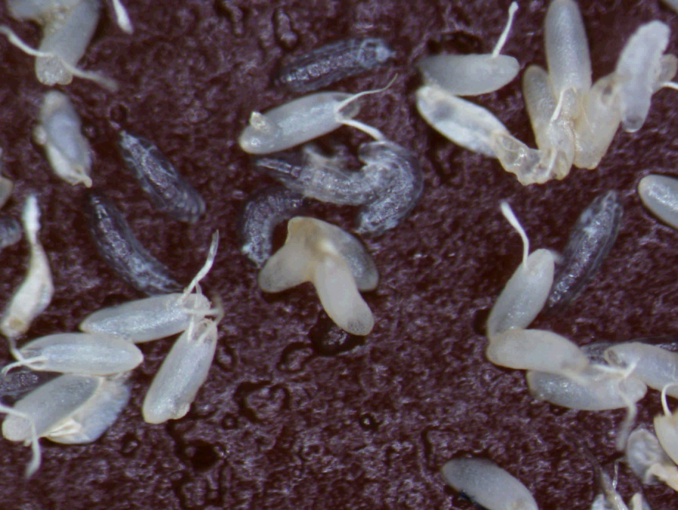
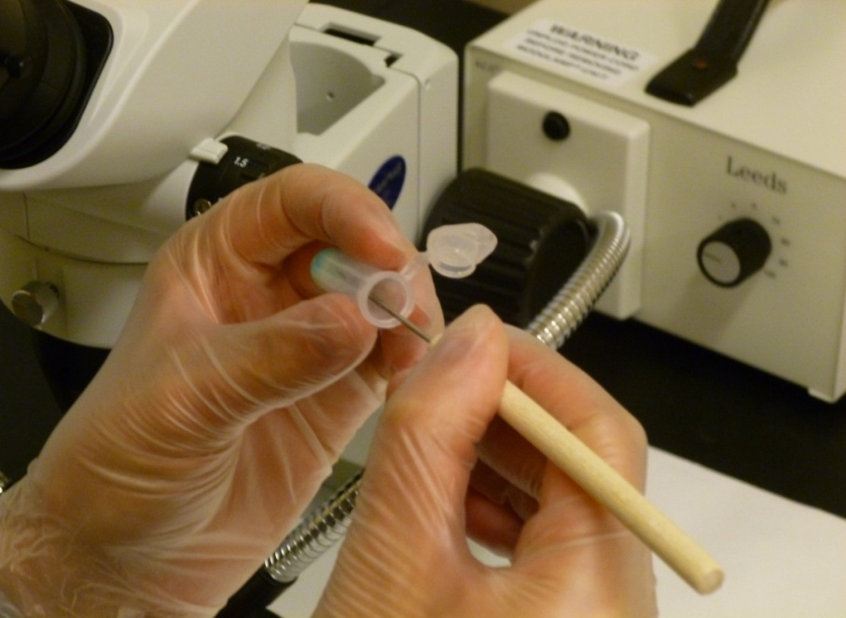
Lay 10 larvae into each wet food tube that you thawed an hour ahead of time. It is important that these food vials are not cold at all because if they are cold, then the larvae will die. Under a dissection microscope, scoop 10 larvae (they must be alive, crawl around and of the approximate size of an egg) with a needle and carefully streak them off onto the wet food in a tube, without touching the wall of the tube to prevent crushing of the fragile larvae. Place the larvae onto the center of the wet food in the 2-mL vial, while watching the tube from the side (not through the microscope). Assure that all larvae have been placed in the food by examining the needle under the microscope. You should scoop larvae in batches of about five larvae at one time. Start with the 0-concentration tubes and place 10 larvae into each tube, close the lids, and poke two small air holes with a thumbtack into the lid. Then do the same with the rest of the experiment, gradually moving to the higher concentrations. Every time you placed 10 larvae into a tube, close the lid and poke the holes into the lids. The air holes shall be sufficiently small to prevent the escape of larvae. Do not poke the thumbtack all the way through the lid because this creates holes big enough for larvae to escape. If you happened to poke all the way through, you can make the holes smaller again by pushing the plastic a bit back, using the thumbtack from the inner side of the lid. Failure to poke holes into the lids will result in the death of all larvae due to oxygen starvation.
When you are done laying your larvae for the entire experiment, double-check that every tube has two air holes. Decontaminate all tools and the work space with 20% bleach, as detailed in the alpha-amanitin control plan. Place the tubes with the larvae into the incubator at 25ºC and 70% humidity in Dow 217 and monitor their development daily. The pupae will form after less than a week on the 0-concentration and later on the higher toxin concentrations. Plan ahead and familiarize yourself with the procedures that you need to analyze the hatched flies. Especially, familiarize yourself with the morphological differences between males and females by looking at the posters on the 5th floor.
Data collection - What do you do when the flies hatch?
Introduction. The effects of alpha-amanitin will be determined based on measurements of the amount of flies that hatch, the sex ratio, the developmental delay (early versus late hatching), thorax length, longevity, and fecundity (eggs per female per day). You need to perform the measurements on the second floor in Dow 217 under the big dissection microscope. Get the flies out of their food tubes once a day because if you let them sit there for longer, they will die and your experiment will become invalid. Depending on the particular experiment, it will not be necessary to perform all the analyses that are listed below. The only measurement that will always be necessary is the number of flies that hatched in every vial. You will be provided with the appropriate data collection sheets, which contain information of what data to collect.
Counting and sexing your flies. Pupae have to be monitored daily for signs of hatching. Black pupae mean that the flies will hatch very soon (the next day if you are watching every day). Hatched flies will be collected at 4 PM every day, counted, and put aside into sugar food vials for overnight storage until the thoraxes are all measured. To count your flies, anesthetize them on a CO₂ pad and count the number of males and females. Write your results down on the appropriate sheet. Males have a dark tip of the abdomen, while females do not have this feature. If you have to measure the thorax length, either do it right away or place your flies into food vials to count them on the next day.
Developmental delay. If you are asked to record the developmental delay, you need to write down when your flies hatched. This is done on a special data sheet that will be handed to you.
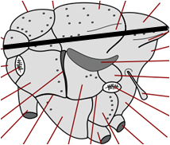
Measuring thorax lengths. Thorax lengths must be measured in um (micrometers) and entered with the notion if the flies are males or females, and on what toxin concentration they grew up. This measurement is an indication for the developmental retardation (decreased size) caused by the toxin in the food. There is a special sheet for entering this data. When measuring thorax lengths, you need to anesthetize the flies on a CO₂ pad, lay them on their side, and use the 20 x magnification both on the microscope and in the imaging software. Use the arbitrary line tool to measure the length of the thorax from the interior margin of the thorax to the posterior tip of the scutellum (as shown by the black line in the picture to the left). Next to the microscope on the second floor, there is a stack of sheets that say “Hatch Counts” on the top. Each day that there are hatches, one of these sheets needs to be filled out. Please fill out the date, experiment number, strain, your name, and the time that the flies are counted in the upper left hand corner of the sheet. As you go through the experiment, write how many flies come out of each vial in the experiment. On the back of this sheet, there is a sheet labelled “Thorax Measurements.” On this sheet you will record the concentration each fly came from, the sex of the fly, and the length of the thorax of the fly.
Longevity and fecundity. Next to the microscope on the second floor, there is a stack of sheets that say “Fecundity Date Tracker.” At the beginning of each experiment, one of these sheets will be started. This is to help you keep track of what flies should be collected for longevity and fecundity studies. Please fill out the date, experiment number, strain, and your name in the upper right hand corner of the sheet. Each alpha-amanitin concentration is treated separately. On the first day you see hatches, count the flies and measure their thorax lengths. Record the date that you see the hatches in the “Date First Hatches Seen” column. For the following three days you will collect the flies, measure their thorax lengths, and place the flies into molasses vials. The ratio of males to females should be 1:1. If there are too many females, add white-eyed males from the w¹¹¹⁸ stock to obtain a 1:1 ratio. Do NOT record these white-eyed males on the tape or on the sheets. We will NOT count them, because we are only interested in the experimental strain. If there are too many males, collect the extra males and place them in their own vial. On the day the flies hatch, the DAY COUNT is ZERO. Record the male to female ratios in the “Ratio” column. Below is an example of what the tape labels should look like (examples in red):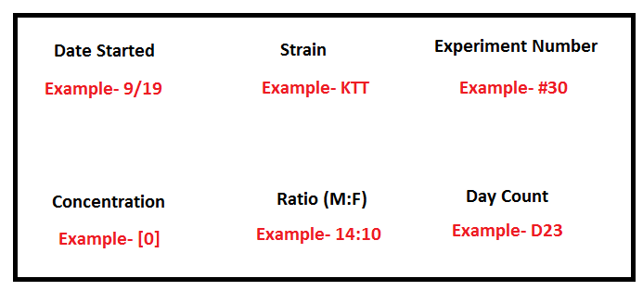
At about the same time on each day, switch the flies from one vial to a new vial with a little yeast paste at the bottom (either by knocking them out on a CO₂ pad or by bumping). Then write a new tape label, making sure to increase the day count and adjust the ratio on the label if any flies died. This will continue until all the flies have died.
In the lab drawer labeled “Egg Counting Sheets” in the fifth floor lab, there is a stack of sheets that say “Longevity and Fecundity Studies.” Please fill out the date, experiment number, strain, your name, and the time that the eggs are counted in the upper left hand corner of the sheet. Count the eggs in the molasses vials. This includes the eggs that have hatched already. Do NOT count the larvae. Eggs could be in the yeast, so make sure you look for them as well. Store the vials with the eggs at 4ºC if necessary, where they will not decay for several weeks. Then take the tape label and fill out the appropriate data into the table found on the sheet. After the eggs have been counted, discard the tape label and molasses in the trash and place the vials near the sink to be washed.
Decontamination of the 2-mL tubes. After there has been a period of three days where you have not observed any fresh hatches, the experiment is considered to be complete. Carefully open all 110 2-mL tubes and place them in a beaker with 50% bleach solution. Let them sit in the bleach overnight and then carefully empty the bleach solution into a sink. The tubes can then be dumped into a garbage can.

